Shabbos Stories for
Parshas acharei mos 5782
Volume 13A, Issue 35 – 29 Nisan 5782/April 30, 2022
Printed L’illuy nishmas Nechama bas R’ Noach, a”h

For a free subscription, please forward your request to keren18@juno.com
Past stories can be found on the website ShabbosStories.com

Defending the
Honor of Orphans

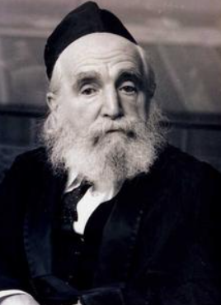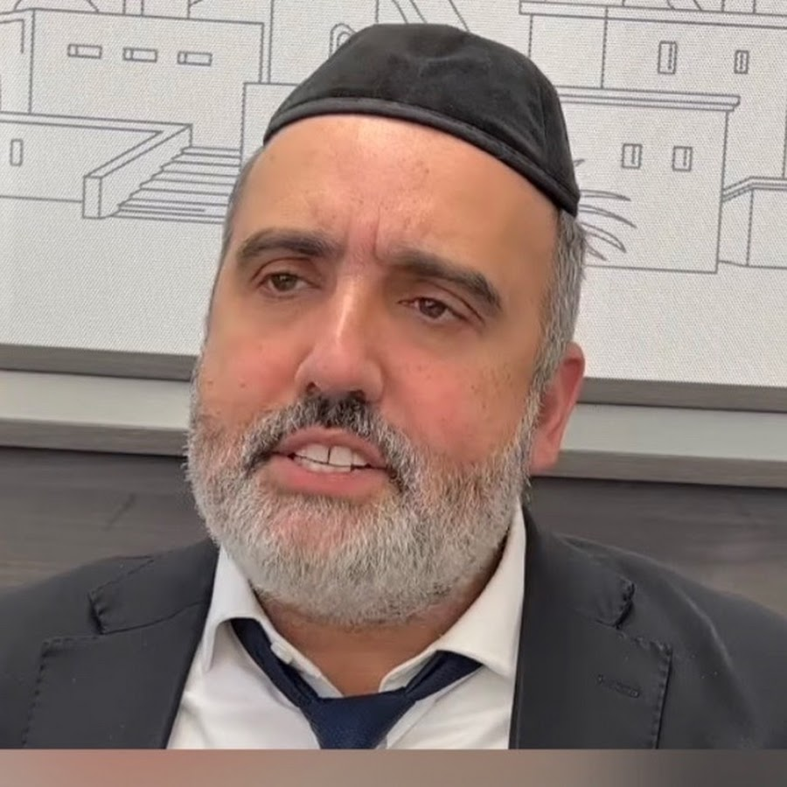
Rabbi Moshe Feinstein and Rabbi Duvi Bensoussan

There was a story told by Rabbi Duvi Bensoussan about Rabbi Moshe Feinstein zt’l. Years ago, right after World War II, there were many orphans that arrived here on American shores, after being left without family. A lot of these orphans were sent to New York to learn in Rabbi Moshe Feinstein’s yeshivah on the Lower East Side. The people involved with the yeshivah started collecting money to buy the orphans clothing.
The president of the shul in the city planned a huge fundraiser, a black-tie dinner, to help collect the money these young orphans needed for clothing and essentials. Everyone from the community was invited to help raise money for them. The well-meaning president stood up in front of all the guests and began to thank the very generous benefactors for their donations for the “Orphans of World War II.”
He said, “I would like to ask the orphan boys in this crowd to stand up and give a respectful hakarat hatov to the donors here tonight.” Of course, these young boys would stand out of humility and respect, but before anyone could get up, Rabbi Moshe Feinstein, Rosh Hayeshivah, shot up from his chair in the front of the room. When the people saw the great Reb Moshe Feinstein standing, the entire room stood up to honor him. And with the whole room standing, no one could tell who was an orphan, and who was not.
The greatness of this gadol was so incredible. With barely a second to think, he immediately reacted and thought about the honor of the children there that day. He was known to have an enormous amount of sensitivity, and just as we learned in Tzav, the Torah goes to great lengths to protect the dignity of those less fortunate.

Reprinted from the Parshat Tzav 5782 email of Rabbi Amram Sananes as written by Jack E. Rahmey.

The Failure of Rebuke

From left to right:
Rav Avraham Pam
And his father Rav
Meir Pam of blessed memories
Rav Avraham Pam elaborated on the importance of humbly accepting criticism. Our instinct upon hearing it is to reject it, to insist that we’re correct and that we have no need to change anything. But if we never accept criticism, we will never grow.
There are many improper things that we do of which we are unaware until somebody draws our attention to the fact that we act wrongly.
Thus, we cannot possibly hope to change and become better if we refuse to accept criticism, to listen with an open mind and ear when people point out to us our mistakes.
Rav Pam related a humorous story about his father, Rav Meir Pam, who served as a Rabbi in Brownsville. Once, Rav Meir found it necessary to harshly rebuke the congregation, and
delivered a speech critical of their conduct. Afterward, one of the members approached him and said, “Wow, Rabbi, you really gave it to them!”
“I had to bite my lip not to laugh or say anything,” Rav Meir later told his son. “He was exactly the person I was talking to!”

Reprinted from the Parshat Tzav 5782 email of Rabbi Amram Sananes as written by Jack E. Rahmey.

The Beauty of Every Jew
By Rabbi Sholom DovBer Avtzon

I recently heard the following prison story.
In the late ’70s or early ’80s, the shliach in Be'er Sheva, Reb Yitzchok Dickstein went to a prison to speak and put on teffilin with the inmates. Being a cheerful fellow many of the inmates gravitated towards him and looked forward to his weekly visit.
One Friday, one of the inmates mentioned to him that there is another Jewish inmate who doesn’t come to this meeting and in fact, he doesn’t leave his cell to meet anyone.
Hearing this Reb Yitzchok said although he doesn’t want to meet me, but I want to see him, and I will go to his cell.
The guards allowed him in and Yitzchok walked over to that person's cell and began a conversation. Contrary to his expectations this inmate was extremely talkative. He began relating his life story and his grievances against various people and the authorities.
Reb Yitzchok not only heard him out but he listened attentively to what he had to say and showed empathy to what he had experienced. After the inmate spoke for a half-hour, he asked, "And why did you come to visit me?"
Reb Yitzchok replied, "I come here every Friday to help the Jewish inmates to put on tefillin. Perhaps you would like to put them on?"
"Definitely," he replied "what do I have to do?"
I will place one of these boxes on your left bicep and the other one on your head and you will say the Shema.
The person rolled up his sleeve and Yitzchok rolled his eyes in disgust. There was a tattoo that perhaps some would say, it is preferable not to put tefillin over it. However, after a moment’s thought, he decided I came so far with this individual, I will put it on.
After the inmate repeated the Shema, Reb Yitzchok wished him a good Shabbos and said I will see you G-d willing next week.
The following week when he came the inmate gave him a strong bear hug and said Rabbi I love you. You are the first person who validated me. You might not have agreed with the actions I took, but you showed compassion for what I endured. Thank you

He then began to roll up his sleeve to put on tefillin and this time Yitzchok was horrified. The inmate's bicep was almost raw. The image was indeed gone but the skin also was all gone
The inmate saw his reaction and said, Rabbi last week I noticed your displeasure with the tattoo I had and I decided to remove it. So every day I took some salt and continued to rub it over the picture until I succeeded in removing it. The only thing is that it also removed some skin that should come back.
Mi kiamcha Yisroel (Who is like Your nation of Israel).

Rabbi Avtzon is a veteran mechanech and the author of numerous books on the Chabad Rebbeim and their chassidim. He can be contacted at avtzonbooks@gmail.com

A Sure Thing

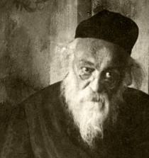
Rav Chaim of Brisk, known as the Gaon of Brisk, was renowned for his compassion.
One day during the reign of Czar Nicholas II of Russia, a young Jewish man was arrested and accused of committing a heinous and revolutionary act, punishable by death. His distraught mother came running to Rav Chaim, crying and imploring him to use his influence on a high official whom he knew, and intervene on behalf of her son. Rav Chaim promised to do whatever was in his power to help free the prisoner.
The Gaon discussed this matter with some of his close associates, who begged him not to get involved. “Don’t endanger your own life by trying to defend this criminal!” they pleaded.

Rav Chaim remained stubborn in his determination. “Let’s examine the facts,” he said. “Pidyon shebuyim (redeeming captives) is definitely a great misvah. That is one fact. That this heartbroken mother is suffering terribly is also a definite fact. But your fears that I might endanger myself by getting involved is only a hypothesis. The Gemara teaches us (Pesahim 9a) that something which is in doubt cannot take precedence over the definite. And all the more so when there are two existing facts…”
Rav Chaim succeeded in freeing the youngster. (excerpted from Glimpses of Greatness by David Koppelman)

Reprinted from the Parshat Tzav 5782 email of Rabbi David Bibi’s Shabbat Shalom from Cyberspace.

The Missing Money
By Rabbi Shlomo Farhi

For many years, my father was a principal in a Jewish day school. A devoted mechanech who looked after the well-being and success of every individual, he saw the development and growth of countless students over the years. Yet, I will never forget one story he related years ago and continues to remain with me to this very day.
On one occasion, a boy decided to bring all the money he had received for his birthday to school. Despite his mother’s advice not to do so, the young boy entered the classroom one morning with $80. Yet, quite quickly, he learned that the words of his mother were wise indeed. Within just a few hours, all the birthday money was gone, and the boy was in tears.
As soon as my father got wind of what had occurred, he knew what he needed to do. He proceeded to call each boy out from the classroom separately and inquire if they perhaps had found the money, knew where it was or accidentally took it and forgot to return it. One by one, the boys filed out of the classroom and into my father’s office for a brief questionnaire.

After seeing half the boys in the class and coming up empty-handed, in walked a boy with something bulging in his back pocket. As it seemed, it was a wallet. “You probably know,” said my father to the boy, “that one of your classmates is missing money. It is his birthday money which he brought to school. Have you seen it around?”
“I haven’t” replied the boy.
“Okay,” swallowed my father. “Is there a chance you took it and planned on returning it, but forgot to? He really feels terrible and it would be a tremendous mitzvah to help him.”
At this point, my father could tell that he was not getting anywhere. So, he tailored his questioning to be just a bit more direct. “I can see that you have a big wallet in your back pocket.”
“Yeah!” enthused the boy.
“Well, how much money do you have in it?” “$79.50!” proudly exclaimed the boy.
“I had $80, but I bought a soda for 50 cents.”
At this point, it was more or less clear to my father that he was dealing with the boy who had taken the money.
“Is there a possibility that this money belongs to the other boy in the class?” The boy continued to hem and haw, denying that the money belonged to anyone else besides him. Nothing seemed to be working.
“It’s a shame that it’s not that money because the boy came to me crying about this birthday money he had been looking forward to receiving an entire year.” Silence filled the office for just a moment, until the boy spoke up, “Oh yeah! This money… I was thinking about another wallet… I wanted to give it back to him, but I got really thirsty and needed to buy a soda…” After a brief period of rationalizing, the boy finally reached into his back pocket and handed over the wallet.
My father proceeded to walk the boy into the classroom and allow him to sit back down in his seat. And then my father did what differentiates a good educator from an excellent educator.
He called the next boy in the class to his office and asked all the same questions he had asked the other boys. And so, he did with the next student and the next student, until everyone in the class had been spoken to.
Why did my father do so? He realized that were he to stop his interrogation after any one particular student in the class, it would be made quite obvious who the thief was. And in the interest of discovering who the responsible boy was, my father was not ready to embarrass anyone. The boy would be privately reprimanded and told of the hurt and harm he caused a fellow classmate, but the larger picture would not be overlooked. My father was pursuing justice and that which was right, but he understood that it could not be done at the expense of embarrassing a student. Pursuing justice must also be carried out with justice.
When faced with situations in which we feel warranted and justified to guide, reprimand and educate our children and students, we can never get carried away. We must carefully weigh our words, actions and reactions and only then make a sound decision as how to proceed. Every situation must be examined individually, but all in all, preserving justice and dignity are to be our guiding lights along the way.

Reprinted from the Parshat Tzav 5782 email of Rabbi David Bibi’s Shabbat Shalom from Cyberspace.

The Baal Shem Tov, a
Poor Chassid and the Wealthy Merchant

When the Baal Shem Tov saw that Reb Dovid, one of his chasidim, was not arranging a match for his daughter, he called in some of his other disciples. “Collect 200 rubles. Take the money to these two addresses, look over the two young men and decide who is more suitable for Reb Dovid’s daughter.”
The chasidim visited both young men and chose the second of the two. They then concluded the engagement to the satisfaction of the young man and his family. The father of the groom told the chasidim, “Take this gift along for the bride and tell her father that I await a similar gift for my son.”
Reb Dovid and his daughter were delighted with the good news and the gift. Reb Dovid tried to put the money together for a gift to send in return, but due to his extreme poverty he was unable to come up with a sizeable sum. Reb Dovid wrote a letter to the groom’s family, assuring them that he would eventually be sending a dowry.
Then, he traveled to the Baal Shem Tov to explain his predicament. The Baal Shem Tov listened compassionately and said, “Do not worry. Trust in G-d and everything will be all right.”
When Reb Dovid arrived home, he found a letter waiting for him from the groom’s family. ‘We have not yet received the dowry. Is it not time for our children to celebrate their wedding?”
Overwrought with worry, Reb Dovid decided to travel once again to the Baal Shem Tov and explain the urgency of the situation.
“I told you not to worry,” the Baal Shem Tov told Reb Dovid. “Go home, put your trust in G-d, and everything will work out well.”
Reb Dovid returned home, but upon his arrival, Reb Dovid found another letter: “We are leaving for your city within two weeks. Please be prepared for us.” “Two weeks,” Reb Dovid read, in sheer misery. He didn’t even have enough food in his house for his own family let alone the groom’s family and all their guests. His only option was to go once again to the Baal Shem Tov. As Reb Dovid neared the Baal Shem Tov’s study hall, one of his traveling companions pointed to a beautiful carriage travelling in front of them and said jokingly, “There is your help.” As it happened, the passenger in the carriage arrived just a moment before Reb Dovid and they both entered the Rebbe’s room together. The Baal Shem Tov greeted only Reb Dovid and said, “I will tell you a story. A wealthy merchant named Reuven lived in Danzig. Once he was returning from a very successful business trip with his bookkeeper and secretary.
“The two men became jealous of their employer’s wealth and plotted to rob him. They attacked the coach driver and beat him to death. They then bound Reuven. “‘Please, spare my life for the sake of my wife and children,’ Reuven pleaded. ‘Take all of my money but spare my life.’
“The two thieves laughed. ‘We cannot leave you alive. Prepare to die.’ “Reuven pleaded, ‘Then give me five minutes to say the final confession,’ “The thieves agreed. While Reuven said the final confession, he wept from the depths of his heart. He called out to G-d, ‘I swear that if my life is spared, I will give one quarter of my fortune to the poor of my family and one quarter to other needy causes.’
“At that moment the sound of hoof-beats were heard. The would-be-murderers fled. It was a nobleman approaching with his servants. Having come upon an abandoned wagon loaded with costly merchandise, they entered the forest to investigate.
“The noblemen sent two of his servants to accompany Reuven home. There, Reuven rejoiced wholeheartedly with his family. After the celebration, Reuven called in a bookkeeper and ordered him, ‘Add up all of my assets.’ “But when Reuven saw what a large sum half of his fortune was, his determination faltered. He decided that giving half of his fortune all at once would break him. He therefore decided to ‘pay it off’ over many years’ time.
“A short while later, Reuven’s wife became ill. The local doctors could not figure out what was wrong with her. They sent Reuven’s wife to specialists who sent her to other specialists. Reuven and his wife traveled from specialist to specialist. But no doctor could diagnose her illness. Finally, Reuven’s wife said to him, ‘Let us go to the Baal Shem Tov.’
“Reuven agreed to his wife’s suggestion,” the Baal Shem Tov concluded. “How much money have you spent on doctors ever since your wife became ill?” the Baal Shem Tov asked the second visitor, finally acknowledging his presence. “Was it not more than a quarter of your fortune, the amount you should have given to the poor? Redeem the rest of your pledge immediately, down to the last penny. You will see that your wife will regain her health.”
Reuven was in shock from the Baal Shem Tov having so vividly described the horrifying events of the past few months. Dutifully, in front of the Baal Shem Tov and Reb Dovid, Reuven emptied his entire purse of money. It contained three thousand gold coins. The Baal Shem Tov gave the money to Reb Dovid and it was not long before his daughter’s wedding was celebrated amidst much joy and happiness.

Reprinted from the Parshat Tzav 5782 email of L’Chaim Weekly, a publication of the Lubavitch Youth Organization in Brooklyn, NY.

The End Does Not
Justify the Means

During the controversy surrounding the implementation of the study of mussar into the yeshivah curriculum (or for that matter, taking time ordinarily dedicated for Torah study and diverting part of it to mussar study or the study of the soul), Horav Yisrael Salanter, zl, the Mussar Movements founder and chief proponent, would upon occasion be harassed by the misnagdim, opposition, to the movement.
This was no different from that which the early chassidim endured in their quest to imbue avodas Hashem, the service to the Almighty, with passion and joy. While today mussar study is an accepted, vital part of Torah study, a time existed in which a number of Lithuanian gedolim, Torah giants, were vehemently opposed to it.
As usual, one could always find rif raf who live for controversy and dispute, who come out of their “holes” in order to disparage and malign anyone who does not agree with them. Rav Yisrael was brilliant and erudite, but he did not call attention to his vast knowledge – focusing instead on the need to study mussar. He was a prolific speaker, who had the ability to captivate, as well as inspire, his audience.

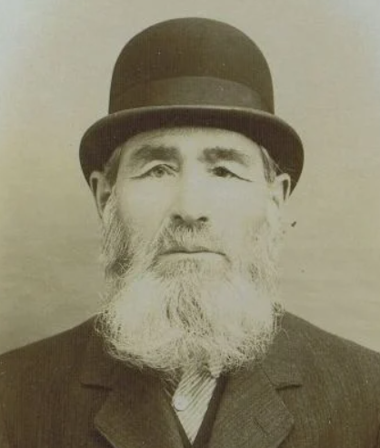
He was asked to give a drashah, lecture, in Vilna, which was a huge Torah centre. His misnagdim, many of whom were quite learned, planned to attend for the purpose of refuting his words, thereby casting aspersion on him, his scholarship, and, above all, the Mussar Movement.
During the shiur, a member of the opposition asked a powerful question focused on the fundamental principle upon which the shiur was based. Rav Yisrael stood thinking for a few moments, then announced that based upon the question presented to him, his entire shiur was refuted. He then left the podium and returned to his seat.
Afterwards, he explained that actually he had twelve answers to the question. They were so compelling that the questioner would be unable to unravel them to see that they did not ultimately answer the question. At the end of the day, however, truth must prevail. If these answers were not an absolute fit, they were false. He would rather have his shiur refuted, suffer the “possible” humiliation, than to agree to settle for anything that was not completely true.
Rav Yisrael confessed that a powerful battle raged within him. On the one hand, admitting defeat imperiled his life’s work. On the other hand, how could he settle for something that lacked integrity? Finally, he cried out to himself, “Yisrael! Yisrael! You learn mussar, and mussar obligates you not to settle for anything that is not absolute truth. This is when I decided to end the shiur.”

Reprinted from the Parshas Shemini 5782 email of Rabbi A.L. Scheinbaum’s Penimim on the Torah.
Dog Food Mishloach Manos
Adapted from the teachings of Rav Avigdor Miller z"l
By A. Ben-Ami

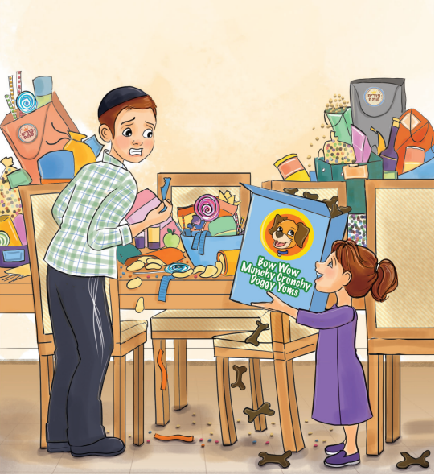
Illustration by Yocheved Nadell

Shimmy went into the kitchen where all of the remaining mishloach manos packages were piled on the table. Wow, there were so many yummy things to choose from! There were taffies and chocolates, hamentashen and rugelach, and what looked like fifty different types of cookies! What should he pick?
Shimmy’s eyes were drawn to one very fancy mishloach package - this one hadn’t been opened yet! Shimmy peeled off the cellophane - inside was a gooey homemade kokosh cake oozing with chocolate - YUM!
Just then, little Yaeli walked in holding a big box. “Hi Shimmy!” she said. “Want some siwial?”
Shimmy looked at the box. “Yaeli!” he exclaimed, wrinkling his nose in disgust. “That’s not cereal, that’s dog food! Where did you find that?” “Next to the stweet!” Yaeli replied proudly.
“Uch, that’s disgusting!” Shimmy said, reaching for the box. “Give me that!” “No! It’s MY siwial!” Yaeli protested, jerking the box away. A few bits of dog food popped out of the bag and flew onto the kitchen table, right as Totty walked into the kitchen.

“At Least it Has a Hechsher”
“Totty,” said Shimmy, holding his nose. “Yaeli is walking around with dog food!” Totty reached down, took the box from Yaeli, and looked at it. “Well at least it has a hechsher,” he said with a laugh, pointing at the kashrus label on the box before throwing it into the garbage and handing her an old spatula to play with instead.
Relieved, Shimmy turned back to the kokesh cake in his hand.
“Wait, Shimmy,” said Totty. “That mishloach manos didn’t come with a card or say who it’s from. So, we can’t eat it - we don’t know who sent it or what the kashrus is.”
“But Totty,” protested Shimmy. “It’s probably fine. I mean who would make kokosh cake with non-kosher ingredients? It’s such a Jewish food! I’m sure it’s kosher!”
“Shimmy,” said Totty. “I know it looks delicious, but would you want to chas veshalom take a chance on eating something that Hashem doesn’t want you to eat? I agree that it’s probably kosher, but why don’t you choose something from items over there that have a good hechsher printed on them?”
Shimmy looked where Totty was pointing. “Blech! Ew! No way! That’s where the dog food spilled!”

Suggests a Strawberry-Vanilla Pudding
“Oh Shimmy,” said Totty looking closely over the table. “I don’t see any pieces of dog food anywhere here. They all went onto the floor. And look - this strawberry-vanilla pudding with chocolate-caramel sprinkles looks absolutely delicious!
“I don’t care,” Shimmy answered. “If there’s even a chance that there was the tiniest piece of dog food in something, I’m not touching it, no matter how good it looks or tastes. That’s what dogs eat!”
Shimmy continued, “my Rebbi told us that Hashem offered Adam Harishon that humans could eat and enjoy grass - that we would never have to work for food since we could just go outside and eat what grows wild in the fields. And Adam Harishon said no, because we’re not animals - we’re a tzelem Elokim - it’s disgusting for us to eat the same thing that animals eat.”
“Ah,” said Totty. “And what about this cake of questionable kashrus in your hand? The same way that humans are better than animals, Yidden are better than humans. We are bnei melochim - we are the sons of the King. We eat royal food. We don’t eat the same food as the rest of the world.
“Other people can eat slimy oysters or pig meat and just shove it into their mouths without a brocha. But we Yidden are extra careful when we eat. We never put something in our mouths without first thanking Hashem for it and we always make sure we know where it came from and that there is no question that it is good for our Neshama.
“You know, I was once at the airport and I saw all of these people walking up to a food stand, buying food, and just eating it. No brocha, no questions about what was in it, just eating without thinking. How can a person just put something into his body without knowing where it came from and without giving thanks to the One who created the food?
“At that moment, as I unwrapped the tuna fish sandwich that Mommy packed for me, I was so thankful to be a Yid - someone who lives and eats like royalty.” Shimmy thought about what Totty said. Then he placed the kokosh cake back in the bag and instead chose a bag of cookies with a clear hechsher and no signs of dog food on it.

Reprinted from the Parshas Shemini 5782 email of Toras Avigdor Junior.

A Good Deed That
Traveled 45 Years
By Alan Magill

Years ago, I worked in a religious nursing home in Williamsburg. There was one man around 90 who I’ll call Shmuel, who liked sharing words of Torah and attending my Oneg Shabbos program on Friday mornings.
One Friday morning, about two minutes from starting, and with a big crowd in the day room, I noticed that Shmuel wasn’t there. Telling the group I would be back soon, I walked to Shmuel’s room, and when I got there I saw him lying on his bed, wearing his suit, tie and shoes, staring up at the ceiling.
I asked, “Aren’t you coming to the Oneg Shabbos?”
With a hurting sound in his voice he said, “I am not going anywhere.” “What happened?'” He said under his breath, “The aide came in this morning and insulted me and since then I don’t want to do anything.”

A Time to Change the Subject
He seemed so locked into his bad mood and I did have people waiting for me. But I wanted to at least try to motivate him to come to this program he loves. So, I changed the subject.
I said, “Shmuel, you never told me what you did for a living.”
He said, “What difference does it make?”
I told him that I wanted to know. He begrudgingly said, “I went around collecting the change from the washers and dryers in apartments all over Brooklyn.” I asked, “What was the most interesting thing that ever happened to you?”
He smiled briefly, and said, “One day, I was in the basement of a building and I had just finished collecting the change there and was about to leave when I saw money on the ground. I picked it up and it was two one-hundred-dollar bills in a rubber band. I wanted to find its owner and return it but I knew that would take time. I went out to the street and found a pay phone and called my boss and asked permission to wait at the building to hopefully return the money.
“My boss told me that I could stay as long as I want, to midnight if need be, as long as I had all of the change from all of the buildings on his desk by 9 a.m. the following morning. So, I went back and waited by the washing machines and a few minutes later a woman came in crying, “I lost the rent money. $200. My husband is going to be so upset with me.

The joy of Helping the Distraught Woman
“I told the lady, ‘You can stop crying. Here is the money.’ When I handed it to her, she was so happy and she thanked me over and over again.” (As he’s telling me this part of the story, I see the energy coming back to his face.) He went on. “It made me feel so good to help her.”
And I loved what he did next. This seemingly immovable person, with energy, got off the bed, and said “Let’s go to Oneg Shabbos.” I happily followed him out the room. If he would have kept that money, 45 years later, sad, in his nursing room bed, it would have absolutely no power to help him. But the kind deed he did stretched across 45 years, energized him, and gave him the oomph to get to that Oneg Shabbos program.

Reprinted from the March 20, 2022 email of The Jewish Press.

